Joel Atkinson
January 13, 2026
CSD-430 Server Side Development
Assignment 1.2
Screenshot of Tomcat file in my documents after download:
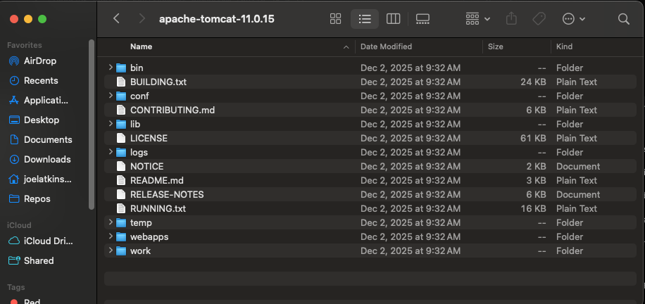
Screenshot of my terminal showing I have Java installed:
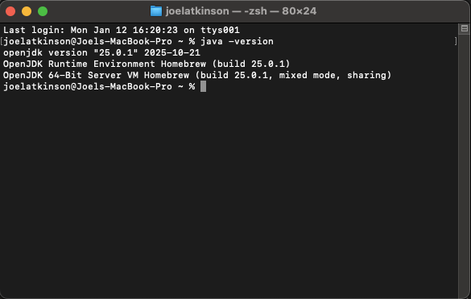
Screenshot of me creating a new Jakarta EE project in my IntelliJ IDE with my downloaded Tomcat file listed as my application server:
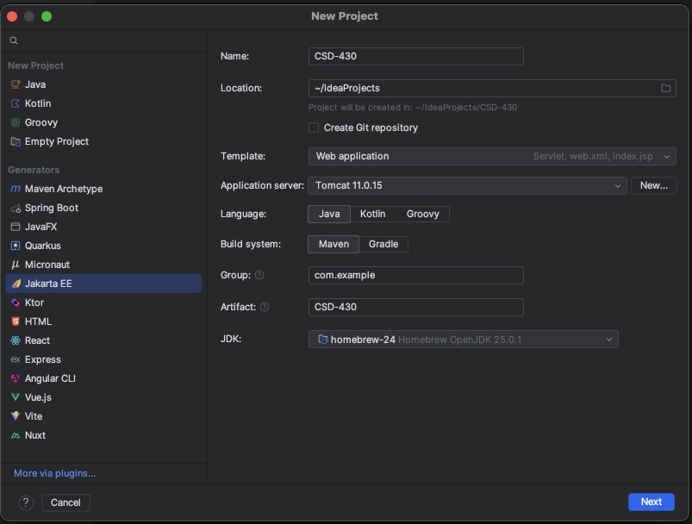
Screenshot of my new IntelliJ project after creating:
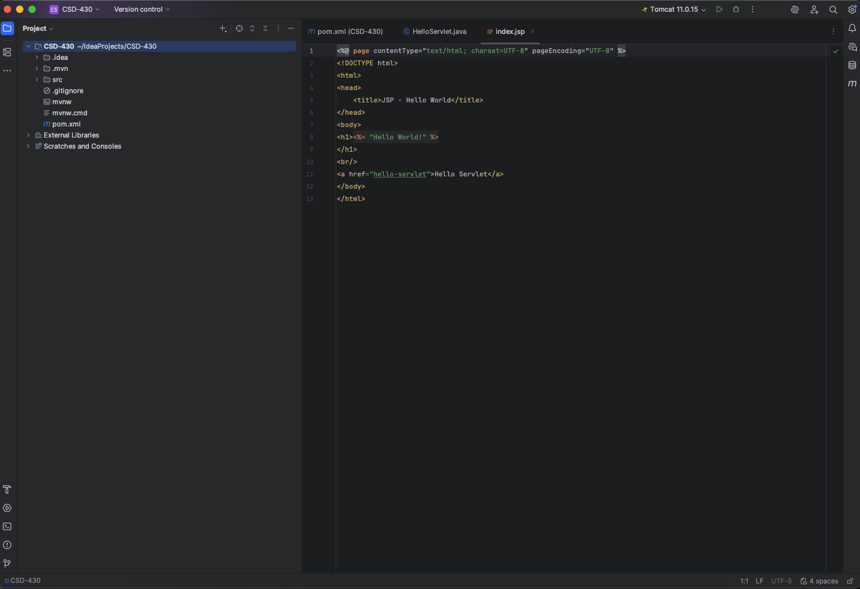
Screenshot of my JSP code running in IntelliJ:
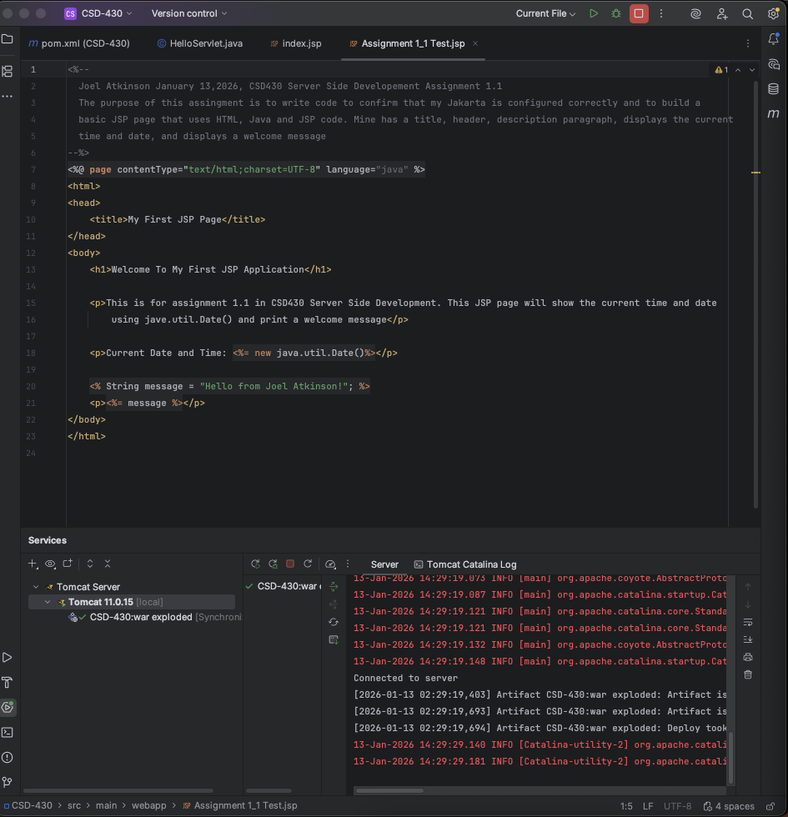
Screenshot of the output of my code opened automatically in a Google Chrome web browser:
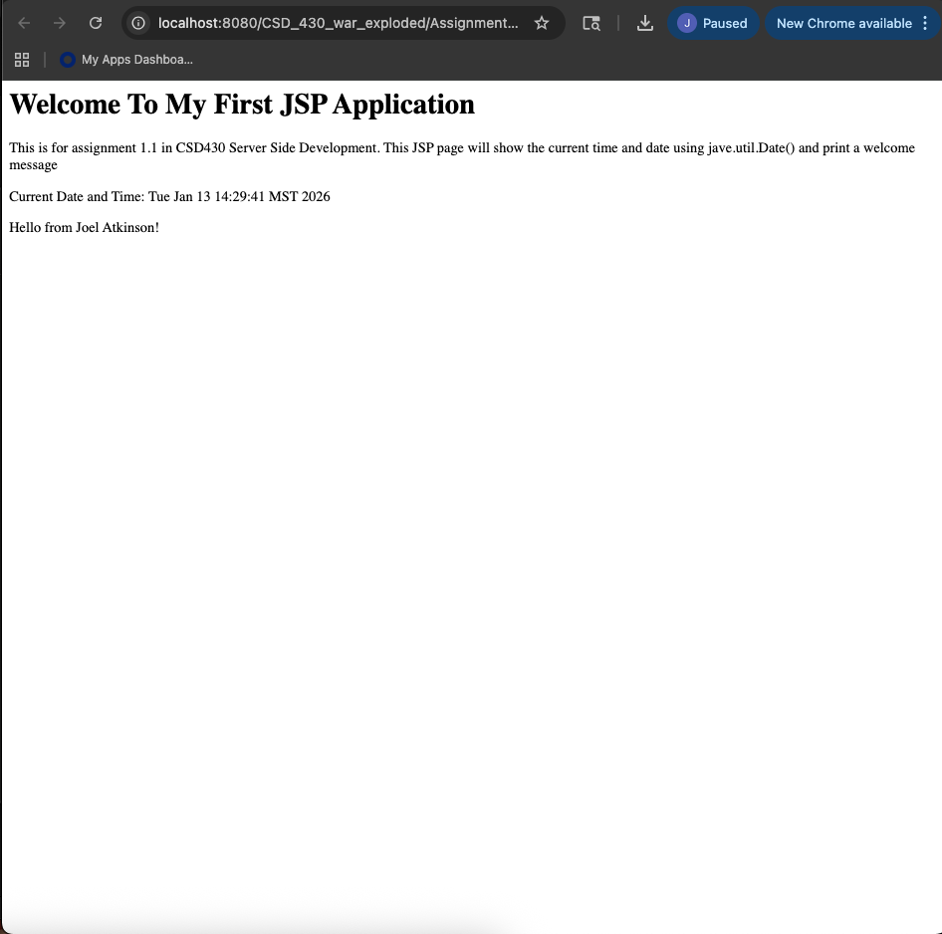
Code:
<%--
Joel Atkinson January 13,2026, CSD430 Server Side Developement Assignment 1.1
The purpose of this assignment is to write code to confirm that my Jakarta is configured correctly and to build a
basic JSP page that uses HTML, Java and JSP code. Mine has a title, header, description paragraph, displays the current
time and date, and displays a welcome message
--%>
<%@ page contentType="text/html;charset=UTF-8" language="java" %>
<html>
<head>
<title>My First JSP Page</title>
</head>
<body>
<h1>Welcome To My First JSP Application</h1>
<p>This is for assignment 1.1 in CSD430 Server Side Development. This JSP page will show the current time and date
using jave.util.Date() and print a welcome message</p>
<p>Current Date and Time: <%= new java.util.Date()%></p>
<% String message = "Hello from Joel Atkinson!"; %>
<p><%= message %></p>
</body>
</html>

